INFORMAL SOLICITATION
RE-BID INVITATION FOR QUOTATIONS
REPAIRS TO THE LAUNDRY ROOM AT HOUSTON MOORE

Date: June 7, 2023 To: Prospective Bidders

LOCATION: Houston Moore Apartments

Housing Authority of the City of Wilmington, North Carolina hereby requests quotations to provide/supply/perform Repairs to Laundry Room at Houston Moore. The firm or individual will provide such services according to the attached scope of work (Attachment A).

In order to receive consideration, quotations must be received by 10:00 am, Wednesday, June 21, 2023, day light savings time. Quotations must be in a marked sealed envelope stating project name along with the required signature HUD forms, Section 3 Certificate, and the bid proposal.

A purchase order checklist is included, which constitutes a complete bid packet submission. Required documents that are not included could eliminate you from the bidding process as non-responsive. If the lowest bidder is not responsive, the Housing Authority of the City of Wilmington has the right to reject the bid and select the next lowest bidder.

Quotations must be submitted on the attached pricing sheet to be considered (Attachment B).

To schedule a walk-through of Houston Moore’s Laundry Facility, please email cburns@wha.net to schedule a date and time.

Sincerely,
Chauntrell Burns
VP of Procurement

Attachments

c:
John Batey, Senior VP of Operations & Development
Cory Peterman, Maintenance Supervisor
File

ATTACHMENT A

Scope of Work

Attachment B

Date: June 7, 2023

For: Repairs to Laundry Room at Houston Moore

Purchase Order Contract Format

The undersigned, company having familiarized with the local conditions affecting the cost of the work, and with the specifications attached, as prepared by Wilmington Housing Authority, hereby propose to furnish all labor, materials, equipment, services, and any incidentals required for the above project at the price (s) listed below. By signing this document, you agreed to the price quoted to perform this project.

All quotes must be delivered on this form to Ms. Chauntrell Burns by Wednesday, June 21, 2023, at 10:00 am. Late submissions are not accepted.
BASE QUOTE:

$________________________ (firmed-fixed price)

_________________________ _____________________
Authorized Signature Date

_____________________________
Print Name:
Company Name
_______________________________________________________
Address
_______________________________________________________
Address
_______________________________________________________
Telephone Number
_______________________________________________________
E-mail address
________________________________________________________
****** Your certificate of liability insurance will be required at the time of the award. *******A five (5) percent bid bond is required for projects greater than $25,000. Attached are the required insurance amounts. Liquated damages of $100/day will be debited to your invoice if the project is NOT completed during the contract period. Worker’s compensation is required with the other coverage. See attached insurance requirements.

THE FOLLOWING TERMS AND CONDITIONS ARE MADE PART OF PURCAHSE ORDER

STATEMENT OF WORK: The Contractor shall furnish all labor, equipment, and services, and perform and complete all work required in accordance with the attached Scope of Work, Contractor's proposal, and Purchase Order.

METHOD OF PAYMENT: Payment for work will be made upon the passing of inspections by WHA Project Manager and final inspection from the New Hanover County Inspection Department if required. WHA payment terms are net thirty (30) days from date of invoice unless otherwise specified on the terms and conditions. Invoice remittance must be uploaded into Vendor’s Café.

***********Lien waiver(s) must be returned signed and notarized prior to release of invoice payments.

TERM OF CONTRACT: The terms of the contract shall be noted in the bid proposal form and/or contract.

INDEPENDENT CONTRACTOR: The Contractor represents to the Authority that it is fully experienced and properly qualified as an expert to perform the work provided for herein and that it is properly equipped, organized and financed to perform such work. The Contractor shall finance its own operations hereunder, shall operate as an independent contractor and not as an agent, or any employee of the Authority and shall hold the Authority free and harmless from all liabilities, costs, and charges by reason of any act, omission or representation of the Contractor of any of its subcontractors, agents, or employees.

It is mutually understood and agreed that Contractor is an independent contractor and not an agent of Housing Authority, and as such, Contractor, his or her agents and employees shall not be entitled to any Housing Authority employment benefits, such as, but not limited to, vacation, sick leave, insurance, worker’s compensation, or pension or retirement benefits.

INDEMNITY: Contractor agrees to indemnify and hold harmless Owner, its independent contractors, agents, employees and indemnities from and against any and all claims, demands causes of action, or other liability, including attorney fees, on account of personal injuries or death or on account of property damages arising out of the work to be performed by the Contractor hereunder and resulting from the negligence of the Contractor's agents, employees or subcontractors. It is the intent of this Section to require the Contractor to Indemnify the Owner to the fullest extent permitted under North Carolina General Statute’s 22B-l.
INSURANCE; Worker’s Compensation: Covering all of Contractors employees to be engaged in the work under this contract, providing the required statutory benefits under North Carolina Worker's Compensation Law, and the employer's liability insurance providing limits at least in the amount of $100,000/500,000/100,000 applicable to claims due to bodily injury by accident or disease.
Comprehensive General Liability: Including coverage for independent contractor operations, contractual liability assumed under the provisions of this contract, products/completed operations liability and broad form property damage liability insurance coverage. Exclusions applicable to explosion, collapse and underground hazards are to be deleted when the work involves these ' exposures. The policy shall provide liability limits for at least for $1,000,000 per occurrence, combined single limits, applicable to claims due to bodily injury, personal injury, and/or property damage. The Housing Authority shall be named as an additional insurer under this policy.
Automobile Liability: Covering all owned, non-owned and hired vehicles, providing liability limits at least in the amount of ' $1,000,000 per occurrence combined single limits applicable to claims due to bodily injury and/or property damage.

The Insurance Certificate shall indicate that the insurance company shall give the Wilmington Housing Authority prior notice of any cancellation or non-renewal in the Contractor's policy.
LABOR REOUIREMENTS: It is hereby specifically and expressly agreed that with respect to labor requirements and wage scales, the Contractor will comply with all statutory and specification requirements, will pay all taxes assessed against his labor, and will also comply with all statutory and specification requirements as to labor reports, payroll taxes, and the like. Contractor agrees to conform to all State and Federal Labor Laws and to the labor policy of the Owner. The contractor agrees to pay any fines assessed against the Owner on account of labor law violations by the Contractor or his Sub-Contractors. Contractor further covenants and expressly agrees that 1) he will not pay less than the wages prevailing in the locality to laborers and mechanics employed on the work, and 2) all laborers and mechanics employed on the work shall receive wage payments of not less than one and one-half (1 1/2) times the basic rate of pay for all hours worked in excess of forty (40) hours in any work week.

SALVAGE AND EXCESS MATERIAL: The Contractor shall leave the job site clean and orderly and shall immediately transport off site any and all salvage material, excess material, and any material that has been removed from WHA Property ("Materials"). In no event shall Contractor allow a WHA Employee or resident to remove Materials from WHA property or premises at any time; nor to have access to Materials; nor to have any rights to materials

unless and until the Materials are transported off WHA property and/or premises and are in the exclusive control of the Contractor. For purposes of this provision, Materials shall
include, but shall not be limited to, new, used or obsolete equipment, building supplies, debris, apparatus, building and construction materials, appliances, etc.
TERMINATION FOR CONVENIENCE: The Contracting Officer may terminate this contract in whole, or in part, whenever the Contracting Officer determines that such termination is in the best interest of the WHA. Any such termination shall be affected by delivery to the Contractor of a Notice of Termination specifying the extent to which the performance of the work under the purchase order/contract is terminated, and the date upon which such termination becomes effective. If the performance of the work is terminated, either in whole or in part, the WHA shall be liable to the Contractor for reasonable and proper costs resulting from such termination upon the receipt by the WHA of a properly presented claim setting out in detail: (1) the total cost of the work performed to date of termination less the total amount of contract payments made to the Contractor; (2) the cost (including reasonable profit) of settling and paying claims under subcontracts and material orders for work performed and materials and supplies delivered to the site, payment for which has not been made by the WHA to the Contractor or by the Contractor to the subcontractor or supplier; (3) the cost of preserving and protecting the work already performed under the WHA or assignee takes possession thereof or assumes responsibility therefore; (4) the actual or estimated cost of legal and accounting services reasonably necessary to prepare and present the termination claim to the WHA; and (5) an amount constituting a reasonable profit on the value of the work performed by the Contractor.

DISPUTES: "Claim" as used in this clause, means a written demand or written assertion by one of the contracting parties seeking as a matter of right, the payment of money in a sum certain, the adjustment or interpretation of contract terms or other relief arising under or relating to the contract. A claim arising under the contract, unlike a claim relating to the contract, is a claim that can be resolved under a contract clause that provides for the relief sought by the claimant. A voucher, invoice or other routine request for payment that is not in dispute when submitted is not a claim. The submission may be converted to a claim by complying with the requirements of this clause, if it is disputed either as to liability or amount or is not, acted upon in a reasonable time.

Except for disputes arising under the clause entitled Labor Requirement herein, all disputes arising under or relating to this contract, including any claims for damages for the alleged breach thereof, which are not disposed of by agreement, shall be resolved under this clause.

All claims by the contractor shall be made in writing and submitted to the Contracting Officer for a written decision. A claim by the Owner against the Contractor shall be subject to a written decision by the Contracting Officer.

SECTION 3: The work to be performed under this contract is subject to the requirements of Section 3 of the Housing and Urban Development Act of 1968, as amended, 12 U.S.C. 1701u
(Section 3). The purpose of Section 3 is to ensure that employment and other economic opportunities generated by HUD assistance to HUD - assisted projects covered by Section 3, shall, to the greatest extent feasible, be directed to low and very low-income persons, particularly persons who are recipients of HUD assistance for housing.

The contractor agrees to comply with HUD regulations 24 CFR part 135, which implements Section 3, as evidenced by the execution of this contract. The contractor certifies that it is under no contractual or other impediment that would prevent compliance with 24 CFR part 135 regulations.

************NOTICES: All notices, which may be given to any of the parties hereunder, shall be delivered or sent by Registered or Certified Mail to the address specified as follows:

Tyrone Garrett, Chief Executive Officer
Wilmington Housing Authority
1524 S. 16th Street, Wilmington, NC 28401
Telephone: (910) 341-7700

__________________________________________
Contractor Signature Date

SUPPLEMENT TO GENERAL CONDITIONS FOR PURCHASE ORDERS GC-1

GENERAL

The following supplements modify, expand certain portions of, or provide additional or more specific information or instructions to requirements of the General Conditions of the Contract for Construction -Public Housing Programs, Form HUD-5370, published by US Department of Housing and Urban Development, applicable specifically for projects by the Wilmington Hosing Authority.

Where any portion of any article, paragraph or clause of the General Conditions is modified or deleted by these Supplementary Conditions, the unaltered provisions of that article, paragraph or clause shall remain in effect.

In case of conflict or discrepancy, the more restrictive requirements shall govern except when specifically modified or rescinded by direct reference or instructions.

CONTRACT PERIOD: The Contractor shall complete all work required under this contract within 1 year of the effective date of the contract, or within the time schedule established in the notice to proceed issued by the Contracting Officer.

LIQUIDATED DAMAGES - Paragraph (a): If the Contractor fails to complete the work within the time specified in the purchase order/contract, the Contractor shall pay to WHA liquidated damages in the sum of $100.00 for each day of delay.

DISPUTES - Failure to complete the project, or any part thereof, on a specified date or dates shall not form a basis for a contractor's claim for extra compensation. No claims by a contractor for extra compensation or adjustments will be allowed on account of deletions of work items or delays or failure of others to complete work.

DEFAULT - If the Housing Authority deems it inexpedient to require the Contractor to correct work injured or not done in accordance with the Contract, an equitable deduction
from the Contract Price shall be made by an agreement between the Contractor and the Authority, subject to prior approval of HUD, and subject to settlement in case of dispute, as
herein provided.

INSURANCE - Each Certificate of Insurance required shall bear the provision that the policy
cannot be canceled nor reduced in amount of coverage nor terminated in less than thirty
days following written notice of such alteration or cancellation sent by registered mail to the
Insured.

Contractor shall furnish WHA with certificates of insurance for the following coverages:

Property Damage Insurance: in an amount not less than $500,000 per occurrence and
$1,000,000 per aggregate and shall include explosion, collapse, and damage to underground
utilities (X, C and U) coverage.

The Wilmington Housing Authority shall be named as an additional insurer under this policy.

Motor Vehicle Liability on owned and non-owned motor vehicles used on the site(s) or in connection therewith for a combined single limit for bodily injury and property damage of not less than $1,000,000 per occurrence.

Worker's Compensation and Employer's Liability Insurance is required in accordance with North Carolina Worker's Compensation Law providing limits at least in the amount of $500,000/$500,000/$500,000 applicable to claims due to bodily injury by accident or disease.

Certificates of Insurance coverage in accordance with above requirements shall be filed with
The Owner.

All sub-contractors shall submit a copy of their certificate of liability insurance to Owner.

EQUAL OPPORTUNITY FOR BUSINESS AND LOWER INCOME PERSONS - All Contractor and/or Subcontractor shall comply with CFR, Part 135, and Implementing Section 3."

________________________________________
Contractor Signature Date

BID PACKET SUBMISSION CHECKLIST

Attachment C- HUD Form 5369-B – your initials on each page
Attachment D - HUD Form 5369-C – your signature
Attachment E- HUD Form 2992 – your signature
Attachment F- HUD Form 92010 – your signature
Attachment G- Section 3 Certificate – your signature

documentation Required upon award;

certificate OF liability INSUANCE INCLUING WORKER’S COMPENSATION

Attachment C
Instructions to Bidders for Contract (Form HUD-5369- B)

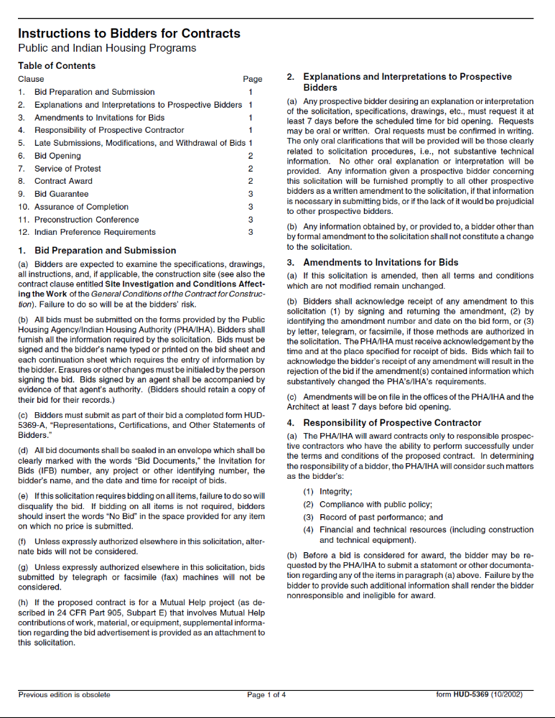
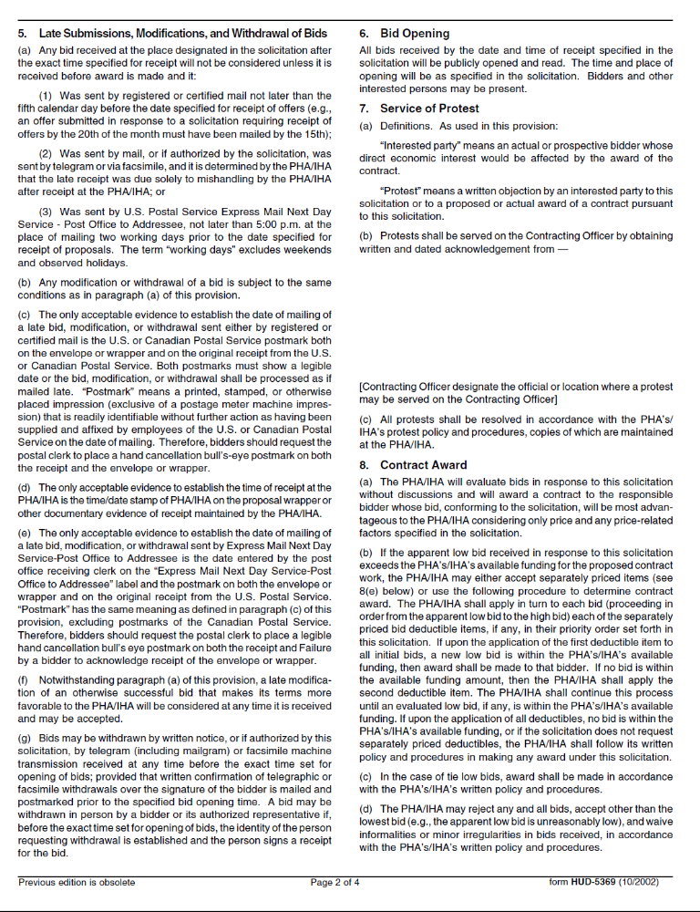
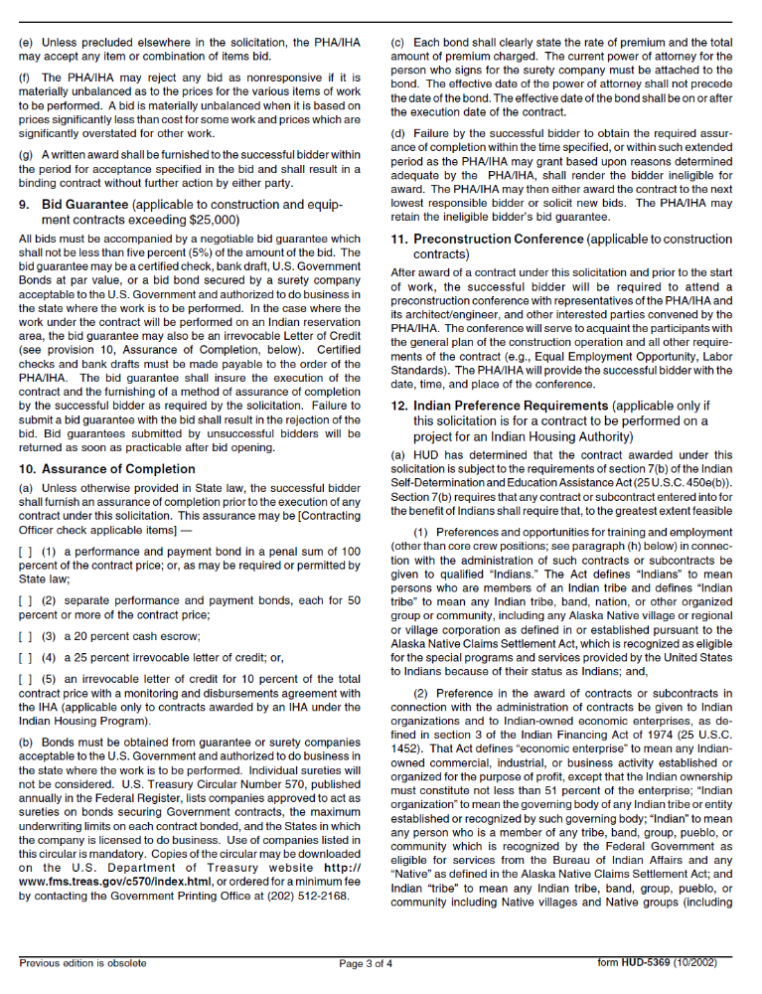
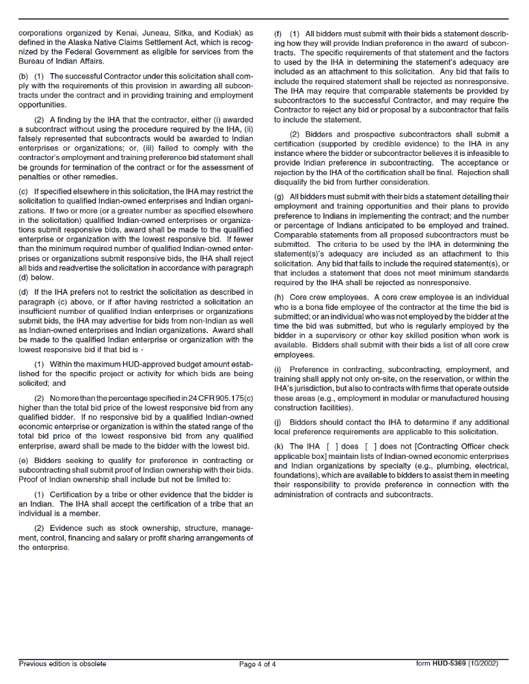

Attachment D. HUD 5369 C
Representations, Certifications and Other Statements of Bidders

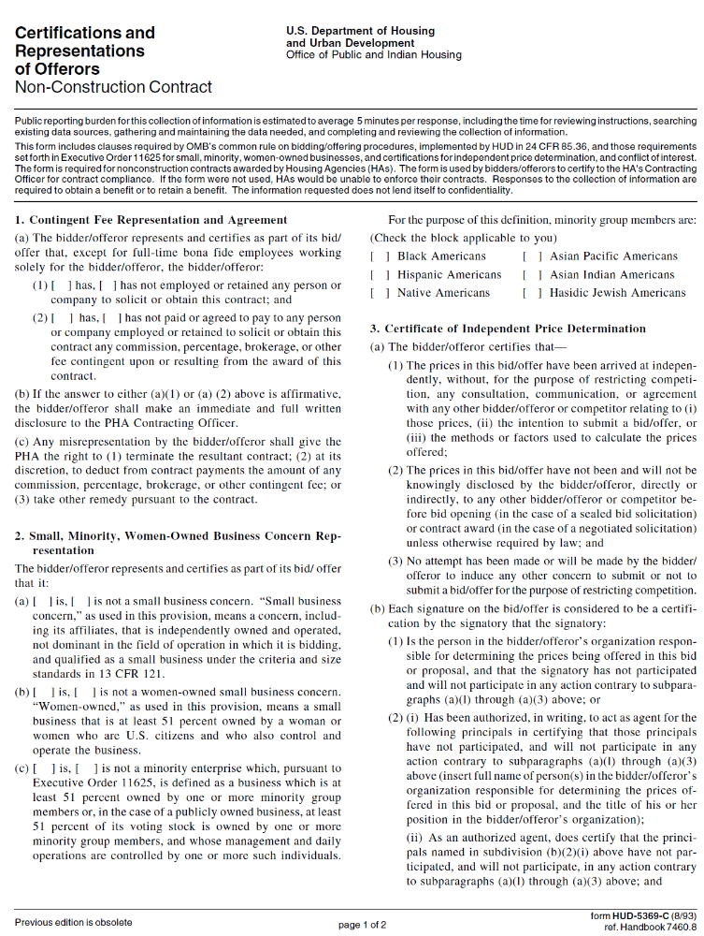
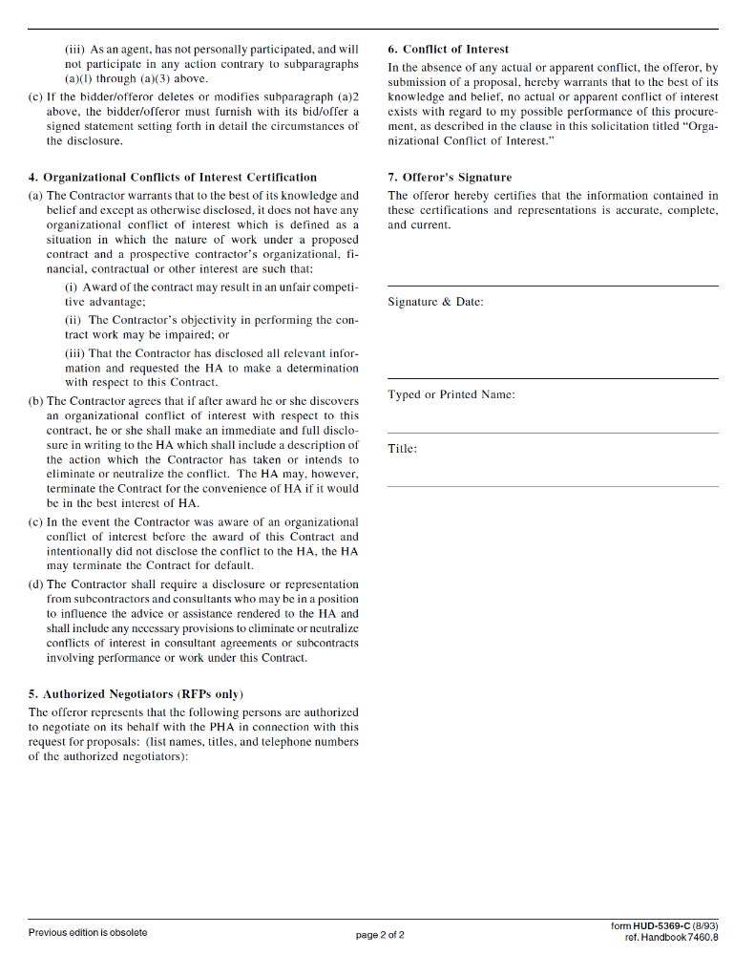

Attachment E
Certification Regarding Debarment and Suspension (Form HUD-2992)

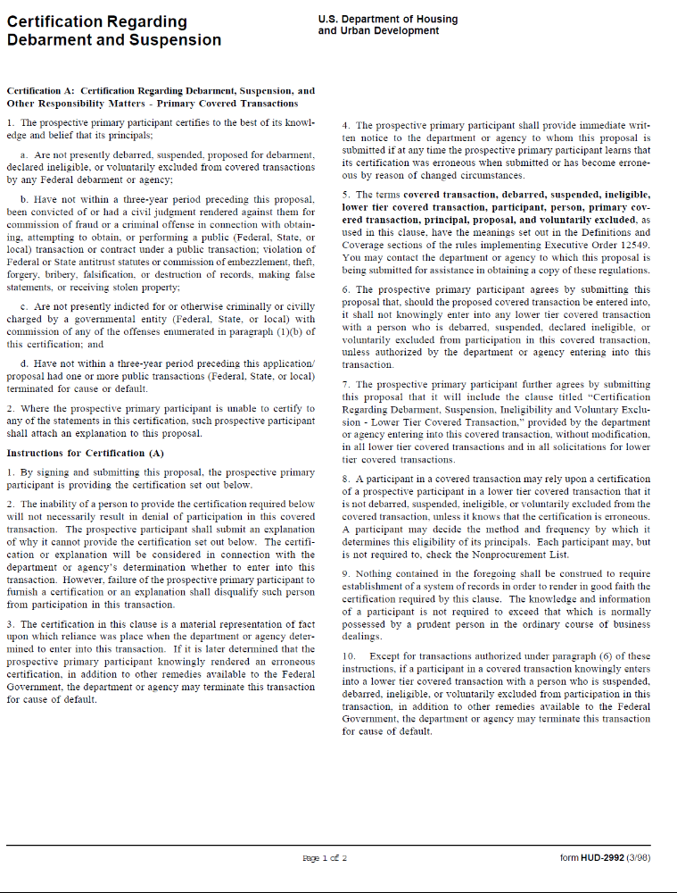
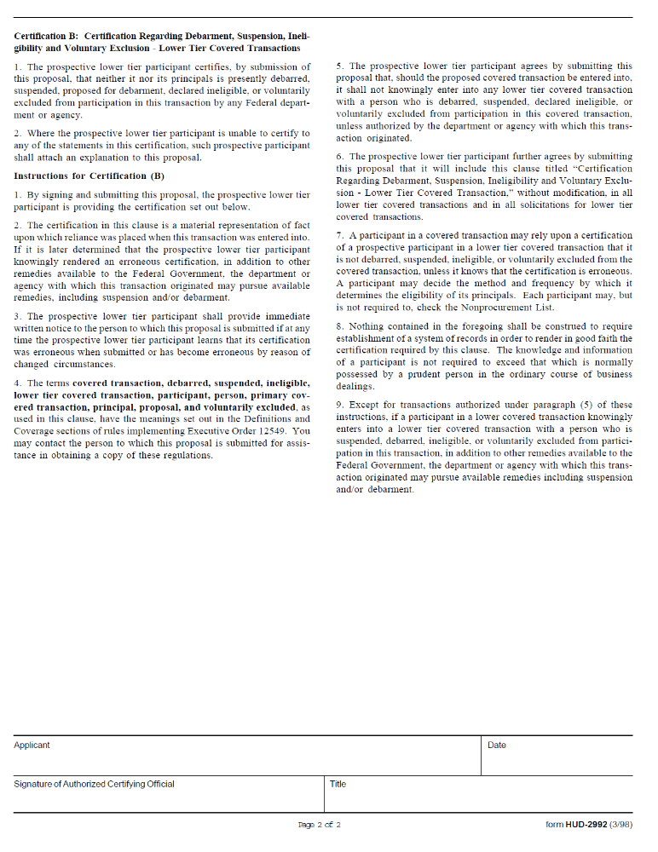

Attachment F

Equal Employment Opportunity Certification (Form HUD-92010)

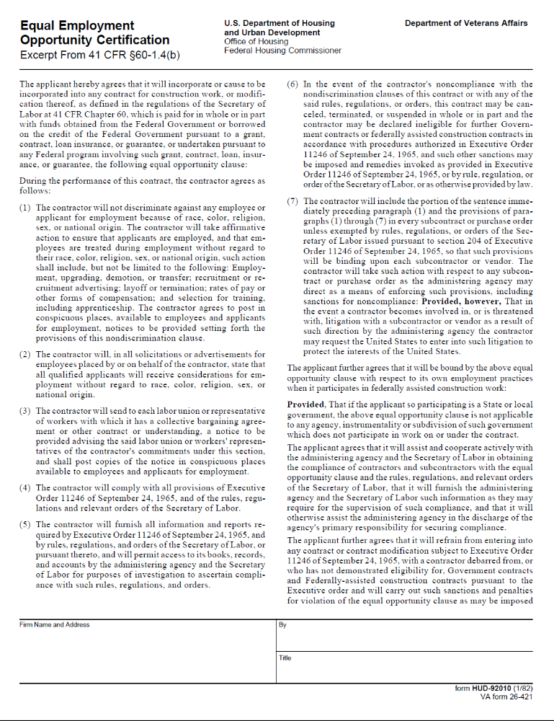
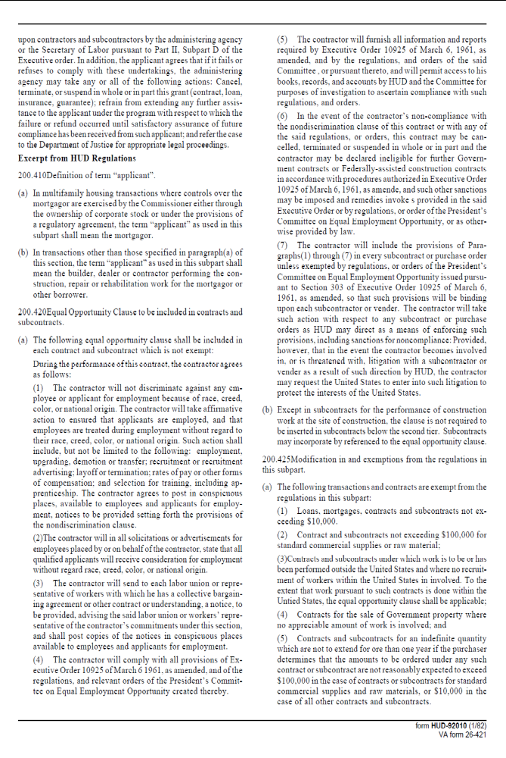
Attachment G

Section 3 Requirements

Section 3 COMPLIANCE CERTIFICATION

The undersigned makes this certification with full knowledge that its contents will be used in the expenditure of funds provided by the United States Government. Under penalty of perjury, I hereby state:

1. I am the ____________________________ of ___________________________, (Owner, Partner, Officer, Representative, Agent)
the Bidder that has submitted the attached Bid; and

2. My company adheres to Section 3 of the Housing and Urban Development (HUD) Act of 1968, as amended, 12 U.S.C. 1701u which requires, to the greatest extent feasible, that a "good faith effort" is given to identifying small businesses located within the boundaries of the Section 3 service area, making them aware of contracting opportunities, encouraging their participation, and actually awarding contracts to Section 3 business concerns.

3. Efforts will be made to undertake outreach activities intended to encourage participation by Section 3 residents in training and employment opportunities, to include but not limited to:

A. Advertising in local media;

B. Distributing flyers on training and job opportunities to public housing sites and posting flyers in common areas;

C. Informing labor organizations and private job training agencies of potential jobs and contract opportunities;

D. Participation in job information meetings and workshops to help Section 3 residents’ complete applications and learn interviewing techniques.

Signature of Authorized Certifying Official: ____________________________________

Title: _____________________________________ Date: _________________________

Company

Name: __________________________________________________________________

